Chittagong University of Engineering &Technology

Department of Electrical & Electronic Engineering

Course No.: EEE 354

Course Title: Measurement and Instrumentation Sessional

Name of the Project:

Temperature Measuring Device using Thermistor

Name: Sree Nirmillo Biswas Tushar,Susanta Devnath,

Ariful Islam

Student No:12002013,1202047,1202060

Section:A

Date of Performance:--10-2015

Date of Submission:4-10-2015

**Table of contents**

|  |  |  |
| --- | --- | --- |
| No. | Name of the contents | Page no. |
| 1 | Circuit Diagram | 3 |
| 2 | Working and design of circuit components | 3-4 |
| 3 | Temperature Vs. V curve (Experimental) | 4 |
| 4 | Curve fitting | 4 |
| 5 | Microcontroller Program | 5 |
| 6 | Comparison between measured data and standard data | 6 |
| 7 | Name and Model no. of used parts | 6 |
| 8 | Price table of each component and total cost | 7-8 |
| 9 | PCB layout | 8-9 |
| 10 | Photo of breadboard implementation | 9 |
| 11 | Photo of PCB implementation | 10 |

**Circuit diagram:**



Figure 01:Circuit diagram of temperature measuring device in VISIO

**Working and Design of Circuit component:**

The use of bridge circuit is very familiar as a transducer in temperature measuring device. In one of the arm of the bridge temperature sensing resistor called thermistor is used in order to make change in the voltage level across the thermistor with the change of temperature. In the left arm two 21 kilo-ohm and a thermistor is connected where in the right arm two 10 kilo-ohm resistor is connected. The voltage across the thermistor is implied on the inverting input of the instrument amplifier AD620 and the 10 kilo-ohm resistor on the right arm is non-inverting input. The resistive value of the thermistor varies from 640 ohm to 42 kilo ohm(approximate) with respective change of temperature from 0 degree centigrade to 100 degree centigrade. So, when it is 0 degree centigrade the AD-620,instrument amplifier, output gives negligible value because voltage, applied to common point of both bridge arm, dividing equally between two 21k resistors and thermistor and so between two 10k resistors. On the other hand, when it is 100 degree centigrade, the output of the instrument amplifier is maximum. this voltage level is read in analog manner by using microcontroller analog pin. Then, A program is developed using the change in voltage level with respect to temperature with a view to measuring temperature. This value is digital write in RB port of microcontroller and is displayed using a LCD display.

**Temp Vs V curve**

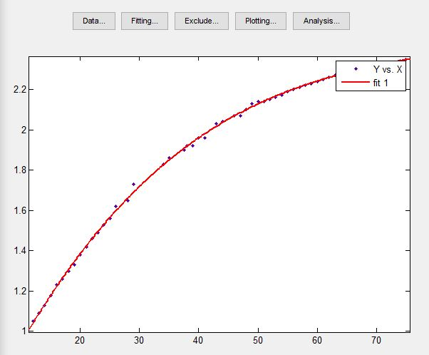

Figure 02:Temperature Vs Voltage curve

**Curve fitting**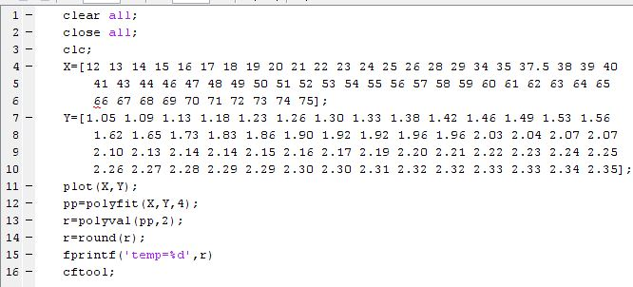

Figure 03:Code for gaining equation of temperature

**Microcontroller Program**

// LCD Module Connections

sbit LCD_RS at RB2_bit;

sbit LCD_EN at RB3_bit;

sbit LCD_D4 at RB4_bit;

sbit LCD_D5 at RB5_bit;

sbit LCD_D6 at RB6_bit;

sbit LCD_D7 at RB7_bit;

sbit LCD_RS_Direction at TRISB2_bit;

sbit LCD_EN_Direction at TRISB3_bit;

sbit LCD_D4_Direction at TRISB4_bit;

sbit LCD_D5_Direction at TRISB5_bit;

sbit LCD_D6_Direction at TRISB6_bit;

sbit LCD_D7_Direction at TRISB7_bit;

// End LCD Module Connections

// Output String Declaration

//char start1[] = "WELCOME in";

//char start2[] = "DIGITAL WORLD";

char txt1[] = "Temperature";

char txt2[] = " C";

// Variable Declaration

float in_vo=4.8z6;

float adc_val,out_vol,temp,sum_temp,avg_temp;

float a;

char temp_str[6];

int i;

float p1 = 50.88;

float p2 = -308.7;

float p3 = 703.7;

float p4 = -684.4;

float p5 = 251;

// Main Function

void main(){

Lcd_Init(); // Initialize LCD

Lcd_Cmd(_LCD_CLEAR); // Clear display

Lcd_Cmd(_LCD_CURSOR_OFF); // Cursor off

Lcd_Out(1,1,txt1);

Lcd_Out(2,6,txt2);

while(1){

adc_val=adc_read(2);

a=(adc_val/255)*4.86;

temp=p1*a*a*a*a + p2*a*a*a + p3*a*a + p4*a + p5;

FloatToStr(temp,temp_str); // Float to String Conversion

temp_str[5]=0;

Lcd_Out(2,1,temp_str); // Output on LCD

delay_ms(1000); // Time Delay

}

}

**Comparison**

The following table shows the comparison of the measured value by developed thermometer with standard meter

|  |  |  |  |
| --- | --- | --- | --- |
| No. of Observation | Measured value using developed  Digital thermometer in degree centigrade | Measured value using standard  Analog thermometer in degree centigrade | Error in degree centigrade |
| 1. | 66.5 | 65 | 1.5 |
| 2. | 55.7 | 55 | 0.7 |
| 3. | 53.88 | 53 | 0.88 |
| 4. | 52.17 | 51 | 1.17 |
| 5. | 50.5 | 49.5 | 1 |
| 6. | 49 | 48 | 1 |
| 7. | 47.5 | 46.5 | 1 |
| 8. | 44.94 | 44.5 | 0.44 |
| 9. | 43.72 | 43.5 | 0.22 |
| 10. | 42.5 | 42 | 0.5 |
| 11. | 41.48 | 41.5 | 0.02 |
| 12. | 40.54 | 40.5 | 0.04 |
| 13. | 38.5 | 38 | 0.5 |
| 14. | 37.63 | 37.5 | 0.13 |
| 15. | 36.78 | 37 | 0.22 |
| 16. | 35.9 | 36 | 0.10 |
| 17. | 32 | 32.5 | 0.5 |
| 18. | 14.5 | 15 | 0.5 |
| 19. | 15.4 | 16 | 0.6 |
| 20. | 16.6 | 17 | 0.4 |

**Parts used**

1. Fixed resistor(10k,21k)
2. Variable resistor
3. Capacitor(100 uF)
4. Instrumental amplifier(AD620)
5. Thermistor(10k)
6. Microcontroller(PIC16F73)
7. LCD display(16×2 display)
8. Voltage regulator(7805)
9. Battery(6F22 9 Volts)
10. Connecting wire
11. Male and Female header
12. IC rail
13. Printed Circuit Board

**Price table**

The table below shows the cost of different components

|  |  |  |
| --- | --- | --- |
| No. of component | Name of the component | Price  In Taka |
| 1 | Fixed resistor(10k,21k) | 6 |
| 2 | Variable resistor | 5 |
| 3 | Capacitor(100 uF) | 5 |
| 4 | Instrumental amplifier(AD620) | 450 |
| 5 | Thermistor(10k) | 10 |
| 6 | Microcontroller(PIC16F73) | 65 |
| 7 | LCD display(16×2 display) | 170 |
| 8 | Voltage regulator(7805) | 5 |
| 9 | Battery(6F22 9 Volts) | 70 |
| 10 | Connecting wire | 20 |
| 11 | Male and Female header | 10 |
| 12 | IC rail | 15 |
| 13 | Printed Circuit Board | 50 |
| 14 | Lead,Fecl3 | 25 |
|  | Total cost | 906 |

**PCB layout**

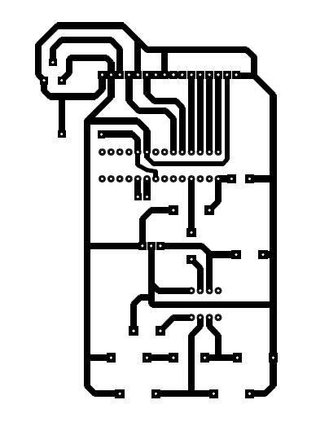

Figure 04:PCB layout of using software

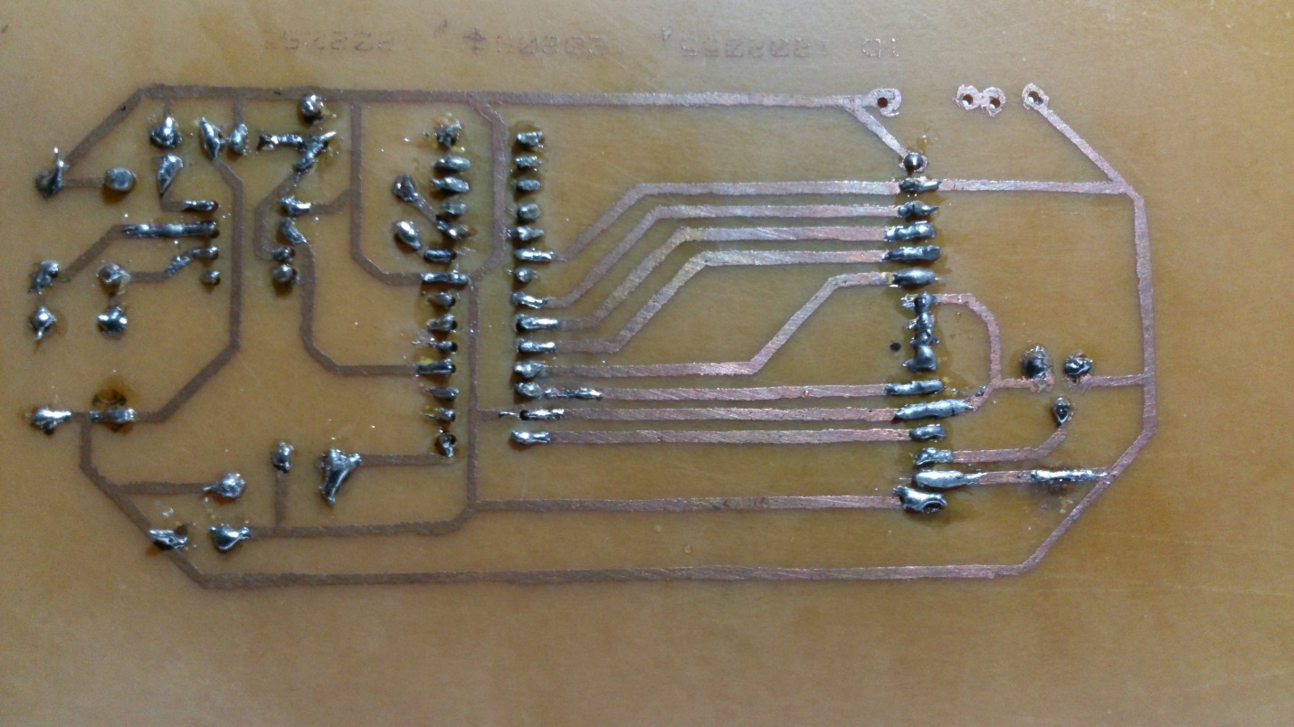

Figure 05:PCB layout

**Photo of breadboard implementation**

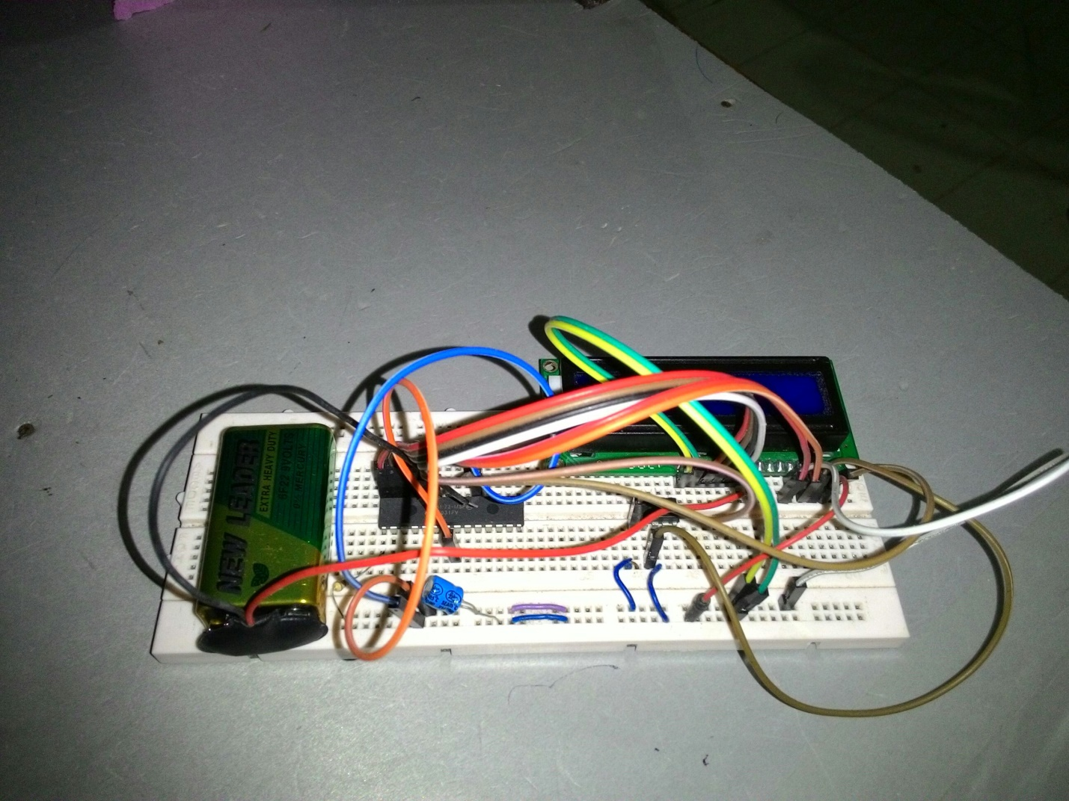

Figure 06:Breadboard implementation

**Photo of PCB implementation**

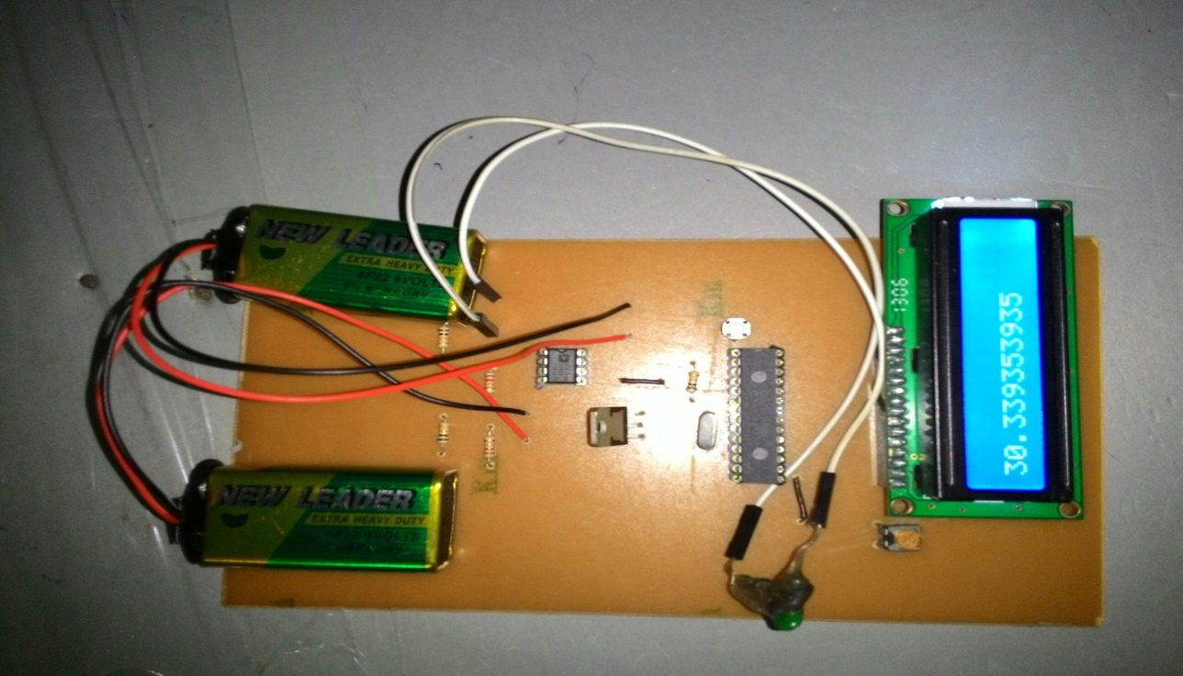

Figure 07:PCB implementation